Blow hot, blow cold

- When we breath out air from our mouth in winter we notice a smoke or cloud near our mouth. Why?
Ans- When we breathe out in cold weather, our warm breath meets the chilly air. This causes the water vapour in our breath to condense and form tiny droplets creating mist. This mist is visible as “smoke” coming out of our mouth.

- Why are ventilators placed near the ceiling?
Ans Hot air rises as it is less dense. So ventilators are placed near the ceiling so that hot air can rise and cool air can settle down.

- Describe the process of respiratory system with the help of a diagram. Also mention the important organs that are involved.
Ans- The respiratory system is a group of organs that work together to bring oxygen into the body and remove carbon dioxide:

Process
When we inhale, oxygen enters our body through nose and passes through trachea, which is connected to the lungs. The lungs have millions of air sacs in it called alveoli. The inhaled oxygen from the lungs is absorbed by blood and is carried to all parts of our body. The oxygen is absorbed by our body which is later used to break down food and release energy. Carbon di oxide, a waste product, is released in this process which we exhale out of our body.

[Note- An average adult human has 4-5 litres of blood
It circulates all over the body every 2 to 3 mins]
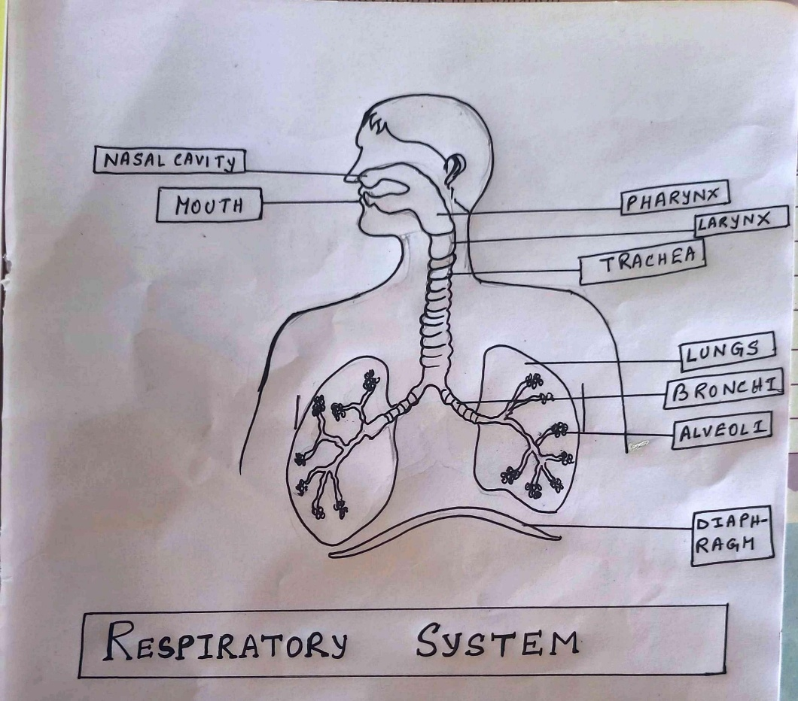
Main organs involved-

- Nose: Air enters through the nostrils.
- Trachea: Air passes through the throat.
- Lungs: Air sacs where oxygen is absorbed.
- Diaphragm: Muscle that helps the lungs to expand.

- Diaphragm is an important part of respiratory system. Mention its important in the system.
Ans- The diaphragm plays a critical role in the respiratory system. When we inhale, our diaphragm contracts and flattens, moving down towards our abdomen. This movement creates a space in your chest, allowing our chest to expand and pull in air. When we breathe out, our diaphragm relaxes and curves back up and our lungs push the air out.

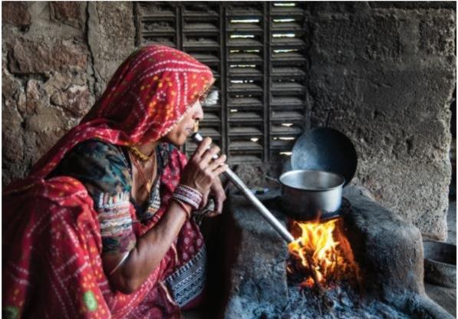
- Why do we blow on the burning pieces of wood while cooking in a chulha?
Ans- Air is blown on burning wood in a
chulha (stove or hearth) to increase the
supply of oxygen, which is essential for
combustion. Blowing on the fire helps it
burn by maintaining continuous supply of oxygen.

- Why do we blow air on the spectacles before cleaning them?
Ans by own

- Why do we breathe heavily after we stop running?
Ans by own

